How does contagious infection spread among city population?
Course project for UCSD/Coursera Java programming specialization
Final project report
Ilya Semenov
21/04/2016

Overview
Goal of the project is to model epidemic effect of a virus inside a population of a small city.
Data
Facebook links snapshot provided by UCSD in week 1 assignment suits well since it contains about 15K nodes which is more than enough to make statistically correct judgements. One can fairly reasonable expect that edges structure of UCSD campus links graph represents links among 15K town population. Dataset contains about 886,5K edges, so that on an average each city resident linked to 59 other people that looks fairly plausible.
So in our model each node represents a resident of a city, whereas each edge represents social links with other residents. For the sake of model simplicity we omit age and gender differences. For simplicity reasons we limit the number of circulating virus DNA to 1, while real number of virus types that cause common colds is about two hundred. https://en.wikipedia.org/wiki/Common_cold#Viruses
Brief data overview
Two figures below (made with R plotting) show distribution of UCSD graph nodes vs No of neighbors each node has. There are several extreme outliers with more than 500 friends and about 450 nodes without friends at all.
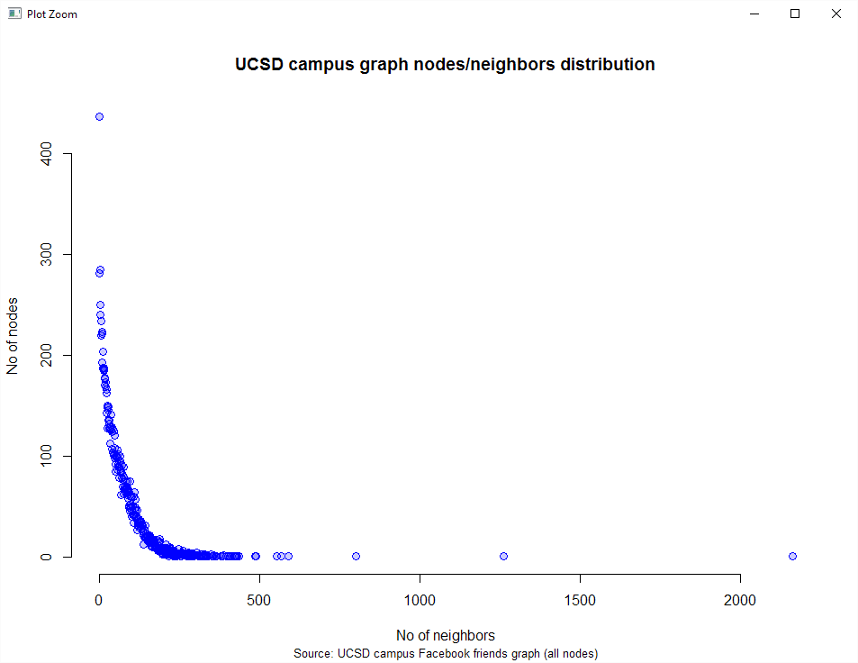
The same distribution with outliers thrown away shows that most nodes have about 80±20 friends that shows our population as relatively strongly connected community. One can reasonably state that such graph structure can represent human social links within a average town.
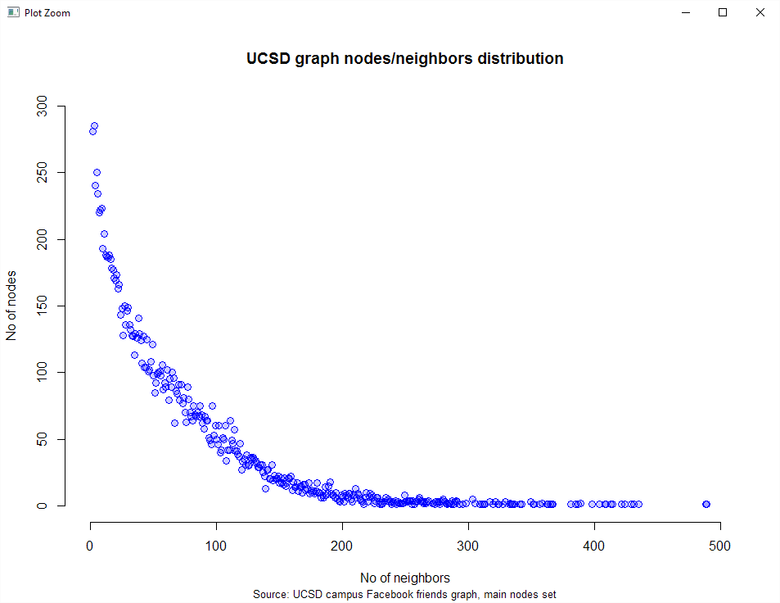

Questions
1. What are the average chances to catch a common cold during winter season (100 days) given fixed virus contamination probability?
2. Are there any features in virus proliferation, i.e. does the virus contaminates rather evenly, or one may talk about more or less stable 'waves' of mass illness, when sufficient number of people feel ill in one-two days? Is it possible to name factors that cause such features, for example probability of catching a cold from one contact, latent period of desease or immunity period after healing?
3. What are the chances of catching a cold twice or more during one season?
4. Assuming we have a vaccine from cold, what minimum level of vaccination should be achieved to prevent epidemic?
5. From the 'virus point of view', is it possible to state minimum probability of contamination by contact, that allows the virus to stay in a population for a whole season?
Algorithm and data structures
Model definition
Every node has one of two basic health states: 'healthy' and 'infected'. Regardless from health state nodes have random number of contacts with each other. This number is limited by 25 per day, in order to limit contacts that are close enough to achieve contamination during the contact. Nodes for contacts are selected randomly from the neighbors of the particular node. Probability of virus contamination during each contact is fundamental virus property and remains unchanged during the simulation. For initial testing this probability were set to 3%.
Once infected each node behaves normally (in terms of number of contacts) for exactly three days, and then the number of contacts is limited to 5, that represents staying home due to illness. Total duration of illness is selected as random number from 5 to 12 days (according to http://www.commoncold.org/understand.htm#whatis). The only possible outcome of illness is complete healing. Once healed node remains immune (contamination probability reduced by 90%) to cold for 40 days.
Main simulation algorithm
I used Graph class as main data structure, that was implemented for week 1 warmup programming assignment.
Basic algorithm is BFS, which is applied N times, where N represents No of days.
Pseudocode for one simulation turn is as follows.
Input: Starting node U (for turn 1 it is already contaminated in preliminary steps)
Output: void (store all changes in graph data structure)
Add U to ToVisit queue
While ToVisit queue isn't empty: *
pop one node E from the queue
Create a List of all E's neighbors **
If E is ill:
Shuffle the List **
Truncate List for first 25 (or less if List is shorter) elements if node is ill for less than 3 days and for first 5 elements otherwise, copy it to another (short) List
Apply Contaminate (sets Ill state and duration with calculated probability) procedure for every node from the List
If this is last illness day:
Set E's state to healthy
Apply SetImmunity (fills No of immunityDays field) procedure
decrease illnessDays field of E by 1
Else: (E is healthy)
decrease immunityDays by 1, if it is > 0
Increase daysInSimulation field by 1
mark E as visited
for every neighbor NE of E: **
if NE has not been visited yet:
add NE to ToVisit queue

Algorithm running time estimate
Is O(n+m), since we visit every node during BFS and check every edge while look for node’s neighbors and Contaminate and SetImmunity procedures both have fixed running times.
Test on real data proved this estimate to be correct since 100 turns simulation takes about 10 seconds for given UCSD Campus graph with about 15K nodes and 886K edges.
Algorithm implementation for questions
For question 1
In addition to main population graph with two hashmaps of vertices and edges I created a separate hashmap with vertices that were contaminated by a virus and No of times they developed illness during one season. After the simulation stopped, No of items in this hashmap divided by No of vertices in the graph gives the answer.
For question 2
First attempt to this question was as follows. Compare No of infected nodes at the end of the day with No of infected nodes at the end of the previous day and if they differ much (say, 5% of the whole population) we state epidemic wave.
After trying some simulation sequences this approach proved to be faulty. It turned out that virus proliferation, in case of vaccination absence, has two basic scenarios despite of any model parameters.
The first one: virus fails to proliferate and fully disappears during at most twenty first turns with contamination rate about 1-7 people in total.
The second one: virus proliferates significantly and survives until the end of simulation cycle. In this case we’ll inevitably notice contamination wave after breaking the barrier (that in fact is staggeringly low) of about 10-15 people become ill. Key wave parameters such as size (top No of simultaneously ill people) and duration are defined by contact contamination probability almost exclusively.
Main difference in case of vaccination present is wave barrier rises to about 20-25 people for most cases.
For question 3
Initial approach. Similar algorithm as for Q1, the only difference is condition for double or more contamination.
Final implementation. Created a counter hashmap in Loader class that was updated every time particular node became ill.
For question 4
Initial approach. The only possible way seems experimental approach when we successively vaccinate at random 25%, 30% ... 80% of nodes, perform full simulation cycle and check if virus survives until the end of a simulation.
Initial approach proved to be satisfactory. Most stunning result is that even low vaccination rates of about 30% have significant influence on virus proliferation chances and contamination wave size.
For question 5
Same approach as for Q4, but this time contamination probability is variable.
Proved to be satisfactory. Most stunning result: contamination probability of 3% is too high. 0,15% seem much more reasonable.
Answers
For Q1 and Q3. Following table gives answers for some examined contamination probabilities.
Key model parameters correspond exactly to initial parameters set given in ‘Model definition’ section.
R statistical software were used to perform summarizing calculations.
Contamination probability during one contact | Infected population rate (mean for 100 simulations) | Infected population rate (mean for simulations with waves only) | Cases of virus self-elimination (% of elimination cases compared to the whole No of simulations) | Top % population ill (mean for simulations only with wave proliferation noticed) | % of population ill twice and more  (mean for simulations only with wave proliferation noticed)
0.03 | 0.758 | 0.842 | 10% | 46.04% | 32.26%
0.02 | 0.518 | 0.647 | 19% | 27.57% | 5.87%
0.015 | 0.295 | 0.483 | 39% | 14.49% | 2.78%
0.01 | 0.014 | 0.046 | 70% | 1.04% | NA

Initial contamination probability seems overestimated since I never heard about half of the city population (acording to column 4 of the table above) suffered from common cold during one day.
Figures below show typical simulation plots for 3% and 1.5% contamination probability accordingly. Each figure shows No of ill people for every day of the simulation.
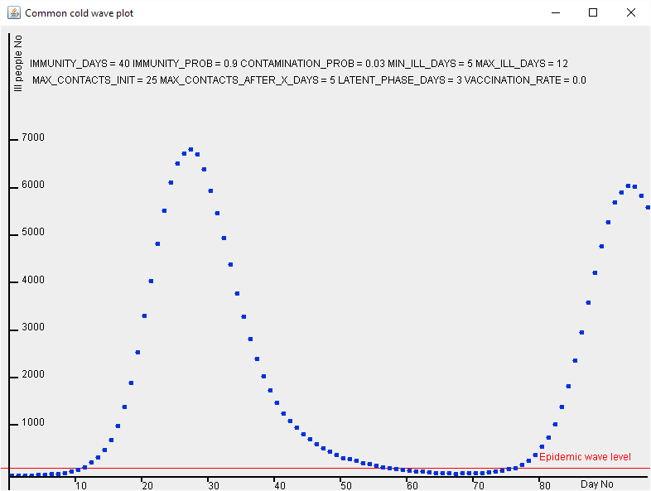
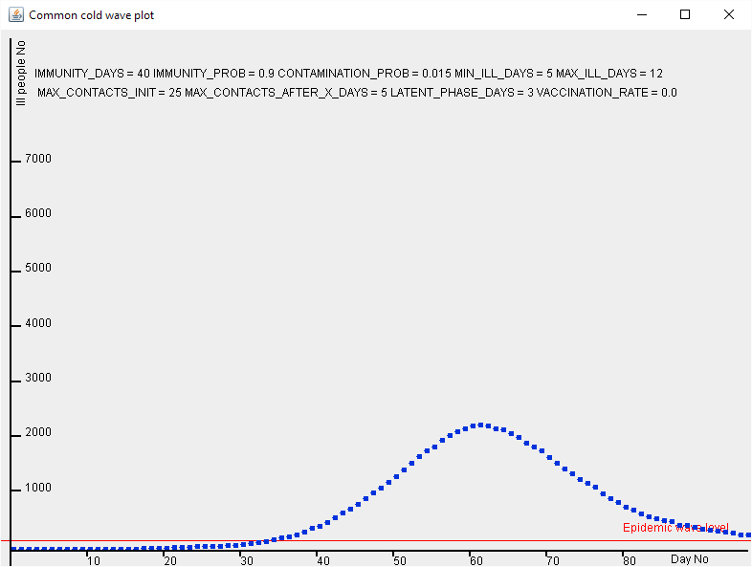
You may find more plots for different contamination probabilities following this link:
https://drive.google.com/open?id=0B_EY_RXYtFKjZ1lUVVRmTlpxVzQ

For Q2
Definitely, yes. There are only two basic types of virus proliferation (on condition there are persons initially immune to virus):
- degenerate case, when virus fails to contaminate sufficient No of people (less than 5 in most cases) and self-eliminates;
- wave proliferation. The only parameter, that defines wave size and shape is contamination probability. Wave parameters for fixed immune probability vary remarkably slightly (for example, variation of wave peak value is less than 2% for any reasonable contamination probability).
For Q4
Vaccines appear to be effective even with relatively small vaccination rates (that is % of vaccinated people among the whole population).
Virus has sufficiently lower chances to proliferate while being introduced to community with only 30% vaccinated humans.
Vaccines also increase the number of persons that should be contaminated to definitely start infection wave, delay wave start and significantly reduce wave peaks.
The effect of 30% vaccination for 0.03 contamination probability virus. Compare with similar figure above that has the same probability and no vaccination.
70% vaccination rate makes even strong 0.03 probability virus practically obsolete.
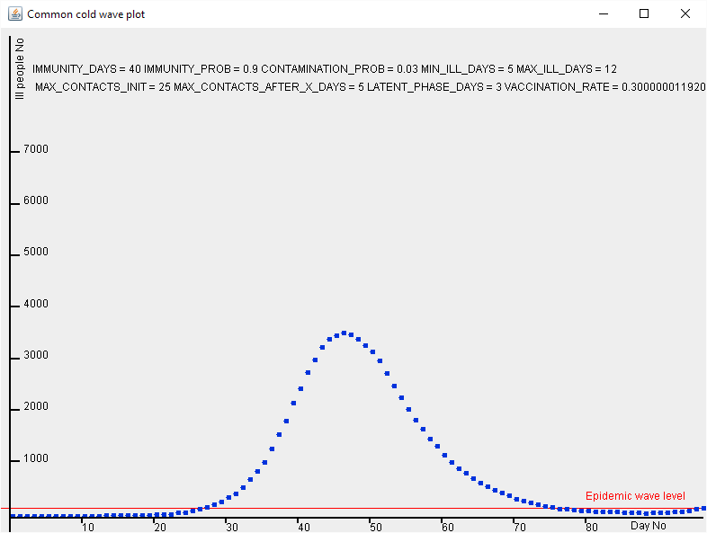
Table below shows vaccination effect for different vaccination rates.
Contamination probability during one contact | Infected population rate (mean for 100 simulations, % of decrease compared with no vaccination) | Infected population rate (mean for simulations with waves only) | Cases of virus self-elimination (% of elimination cases compared to the whole No of simulations) | Top % population ill (mean for simulations only with wave proliferation noticed) | Vaccination rate
0.03 | 0.460 (-40%) | 0.575 (-32%) | 20% | 24.74% | 30%
0.03 | 0.249 | 0.356 | 30% | 11.33% | 50%
0.03 | 0.034 | 0.084 | 60% | 1.76% | 70%

For Q5
Correct answer is as follows: if the virus managed to start infection wave it will probably survive for more than 100 days.
Virus has sufficient chances of wave proliferation if it has managed to contaminate about 10 people (that is surprisingly small quantity). It corresponds to contamination probability that equals or more than 0.015±.002.
Code overview
Class: GraphNode
Purpose and description. Represents a node in a graph. Keeps illness state, illness and immunity duration, days a node is being ill and total days in simulation. All methods are standard getters and setters.
Class: CapGraph
Purpose and description. Represents a graph itself. Main data structures are two hashmaps of nodes and edges. Also has auxiliary hashset of nodes that are currently contaminated. Has standard methods for adding nodes and edges. Main method is simulateTurn() that traverses the graph and performs contamination procedure for randomly selected set of nodes.
* CapGraph actually implements directed graph, so addEdge() method were modified to ensure that every edge is bidirectional.
Class Loader
Purpose and description. A launcher. Contains data loading/initializing code and main loop for turns simulating.
Also performs all output.
Overall design justification
I used adjacency list representation of the graph, almost exactly the same as for week 1 programming assignment. There are surprisingly many additional auxiliary data structures in CapGraph.simulateTurn() that are targeted to correct separate processing of contacts limitation when ill plus still active and ill plus staying home. I also added unintended in first design version excessive contaminatedNodes hashset in order to speed up turn processing.
There is one excessive Boolean data field 'isIll' in GraphNode that was left to make the code a little bit more clear.
Testing plan
As testing dataset I used an 8 nodes graph very similar to one that was showed in a week 1 lecture slides. Testing strategy were approximately as follows:
1. Make sure that all nodes and edges traversed correctly, i.e. once.
2. Test corner cases: not connected graphs, maximum strongly connected graph.
3. Skip all probabilistic elements and test correct illness and immunity duration handling.
4. Test probabilities handling.
Then I ran some 100 days simulations on a provided UCSD campus facebook snapshot dataset.
Project resume

Reflection
Project focus haven't changed at all. I just enjoy simulated epidemic waves :)

